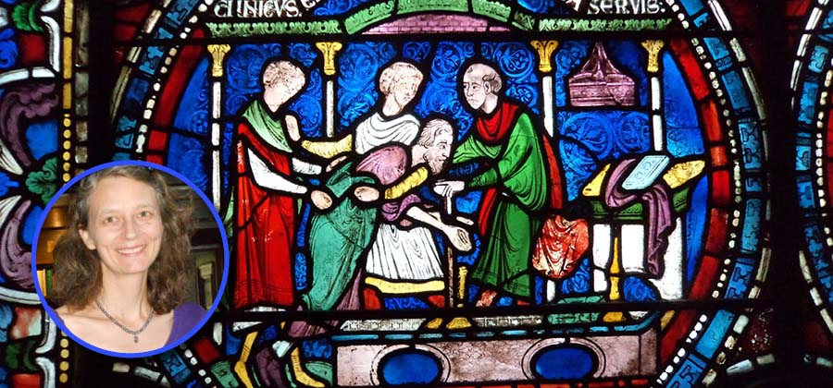

**Annual Becket Lecture (and book launch) organised by the CKHH on Tuesday 27 May 2025 at 7pm (wine reception and bookstall from 6.30pm) in The Michael Berry Lecture Theatre and Old Sessions foyer**

**“Murder, Miracles, Liturgy, and Stained Glass: Thomas Becket and Benedict of Peterborough”**

**Professor Rachel Koopmans**

This lecture will present the argument that the Benedictine monk and later abbot Benedict of Peterborough (d.1193) was the single most pivotal figure in the creation of Thomas Becket’s saintly reputation.  Before any other Becket hagiographer put pen to parchment, Benedict began collecting stories about the new saint’s miracles.  His collection of some 275 stories became by far the most widely circulated miracle collection composed in England, with manuscript copies making their way to Portugal, Poland, Denmark, Italy, Switzerland, Austria, Germany, and Iceland as well as many locations in Britain and France.  Present in Canterbury on the day of the archbishop’s murder, Benedict wrote one of the earliest and most gripping accounts of his brutal death.  It was Benedict who composed the music and text of the liturgical Office utilized throughout Latin Christendom to celebrate Becket’s feast day, a text that draws heavily on his earlier compositions and survives in hundreds of medieval manuscripts.

In addition to all this, it was Benedict’s writings that served as the principal source texts for the glaziers of Canterbury Cathedral as they created the famous Miracle Windows series.  There are very good reasons to think that Benedict was the brain behind the overall glazing programme for the newly rebuilt eastern end of Canterbury Cathedral, with its closely interconnected sequences of Ancestor Windows in the clerestory, Bible Windows in the choir, and Miracle Windows in the Becket chapel.  Benedict was the prior of Canterbury at exactly the right time for the planning of these windows, and his fingerprints look to be all over them.

Benedict of Peterborough is the most important figure in the Becket cult that you’ve never heard of.  This lecture will serve as a launch of *The Passion and Miracles of St Thomas Becket by Benedict of Peterborough*, published by Boydell Press in May 2025. This is the first English translation of Benedict’s remarkable (and very readable) works.

**Rachel Koopmans** has taught at York University, Toronto, since 2006, where she is currently Associate Professor of History. Her book, *Wonderful to Relate: Miracle Stories and Miracle Collecting in High Medieval England* (2011), was awarded the Margaret Wade Labarge Prize for 2012 by the Canadian Society of Medievalists. That same year, she was also awarded a prestigious Insight Grant by the Social Sciences and Humanities Research Council of Canada for her work on the “miracle windows” depicting Thomas Becket in the Trinity Chapel at Canterbury Cathedral. The resulting study, accepted for the *Corpus Vitrearum Medii Aevi* is the first major detailed analysis of the subject. Her recent essays include studies of Christina of Markyate and of the testimonial letters associated with the cult of Thomas Becket, among other subjects. She is currently working on the third of the Becket Miracle Windows to be investigated in the last few years. Her Becket Lecture marks the publication of her modern English translation of Benedict of Peterborough's *Miracles of Thomas Becket*.

*This is a FREE public lecture. No booking is required*.