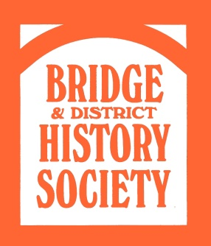**Thursday 18 Sept @ 7.30pm AMY JOHNSON (1903-41) Bridge Village Hall**

**Chairman’s Report on last season**   
**followed by JaneDelamaine’s talk TheLife & Death of Amy Johnson**

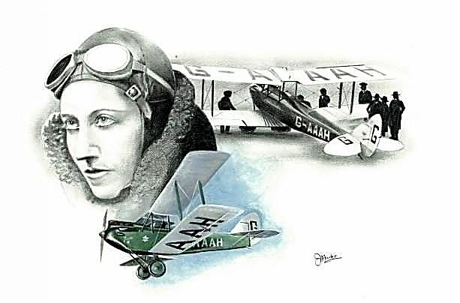

**Amy was the first woman to fly solo from England to Australia in 1930 for which she was awarded the CBE. Sadly this legendary aviatrix died 11 years later when her plane crashed somewhere in the Thames Estuary. Jane pays tribute to Amy and takes us on a journey of her life, her incredible achievements and tragic death.**

**Admission £4 (including refreshments)**